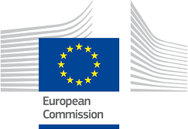
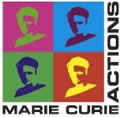
InterTalentum MSCA-COFUND Fellowship Programme at UAM
Second call – Deadline 25th May 2018

Letters of Commitment (Non-UAM institutions and Secondments)

Please use this section only for the Outgoing Phase and secondments, to insert scanned copies of the required Letters of Commitment from the partner organisations. Minimum requirements for the letter of commitment:
• heading or stamp from the institution;
• up-to-date (i.e. issued after the call publication date, 1 July 2016);
• the text must demonstrate the will to actively participate in the proposed action and the precise role;
• signed by the legal representative.

Please note that proposals failing to comply with the above-mentioned requirements will be declared inadmissible.

